Clarence H. De Leus BSIT 2A

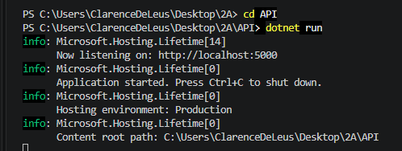
PART 1 - SETTING
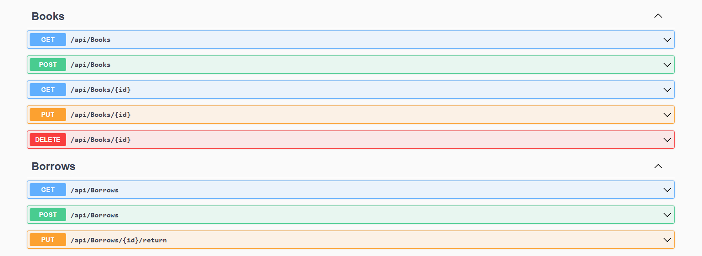
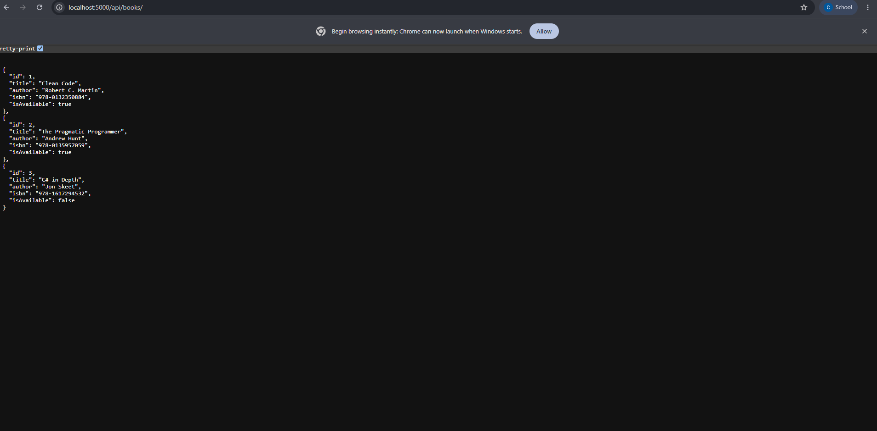

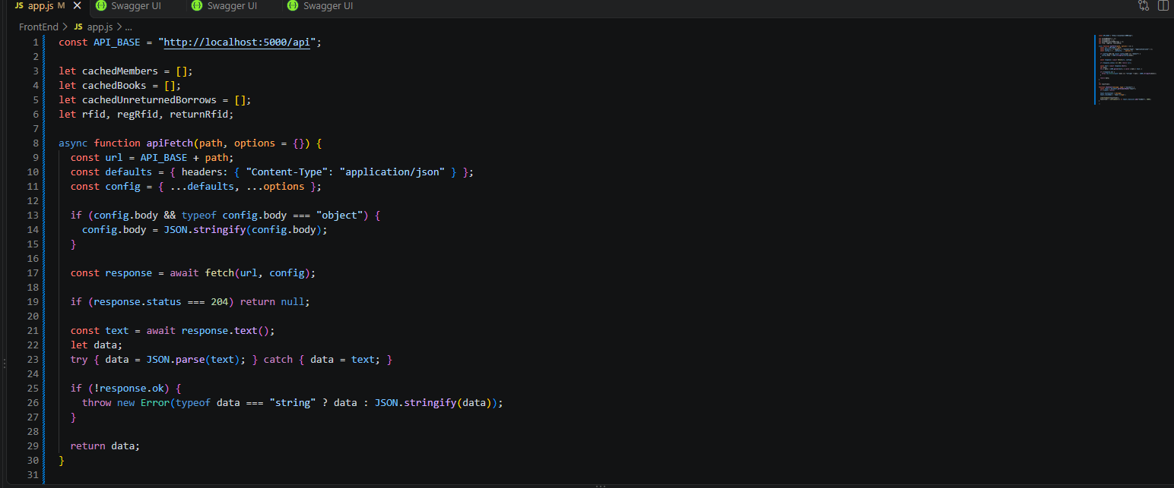
PART 2 - TOAST MESSAGES

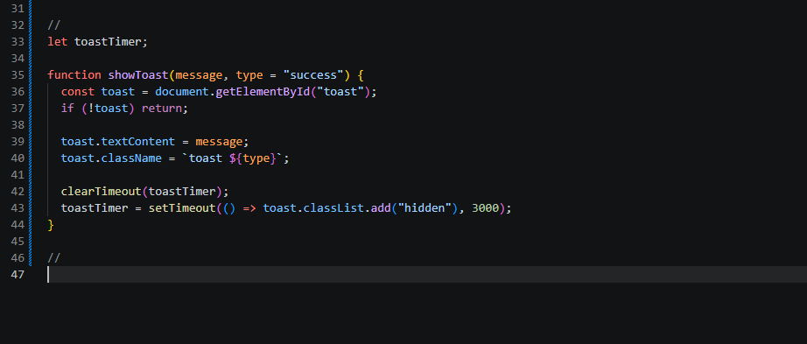
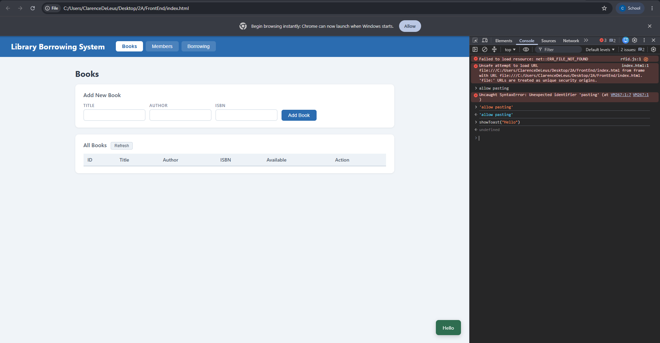
PART 3 - CACHE
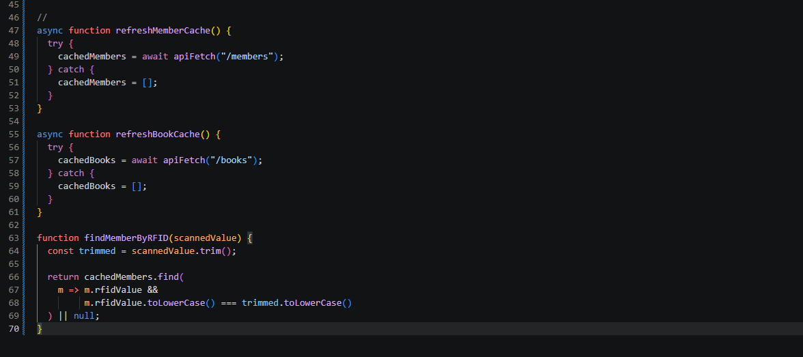
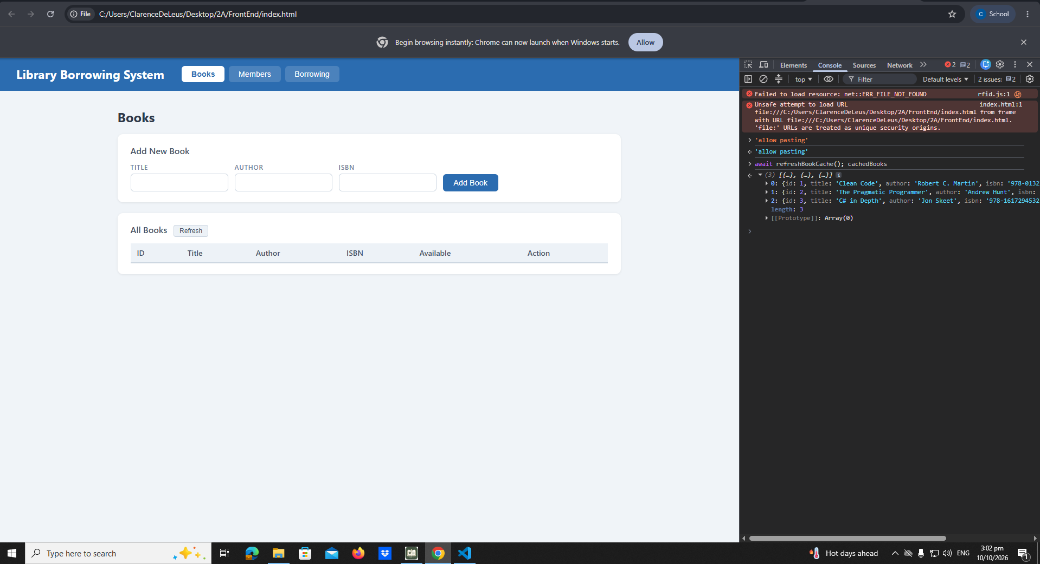
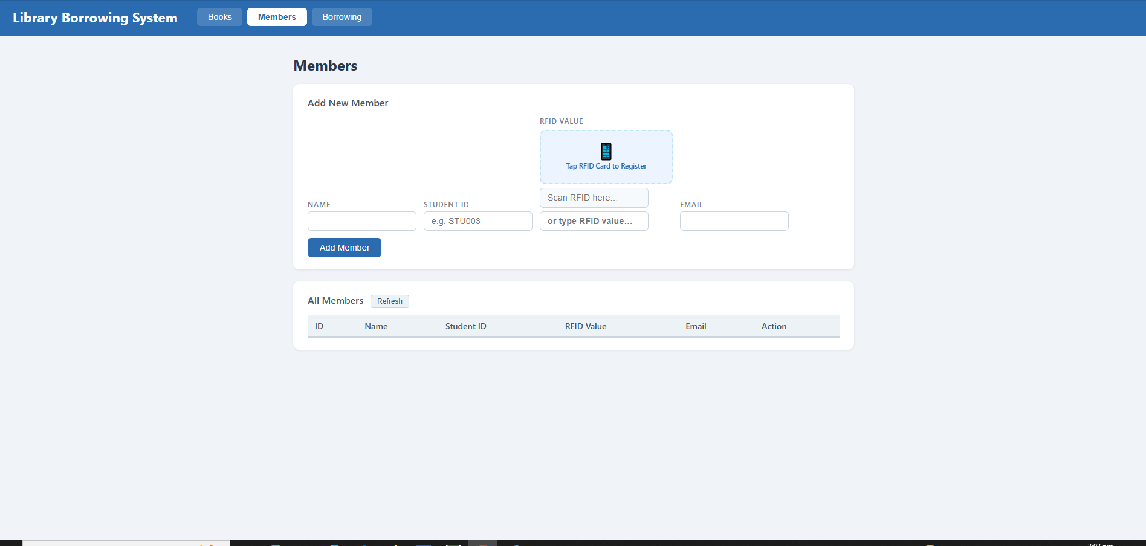

PART 4 - TABS AND REFRESH
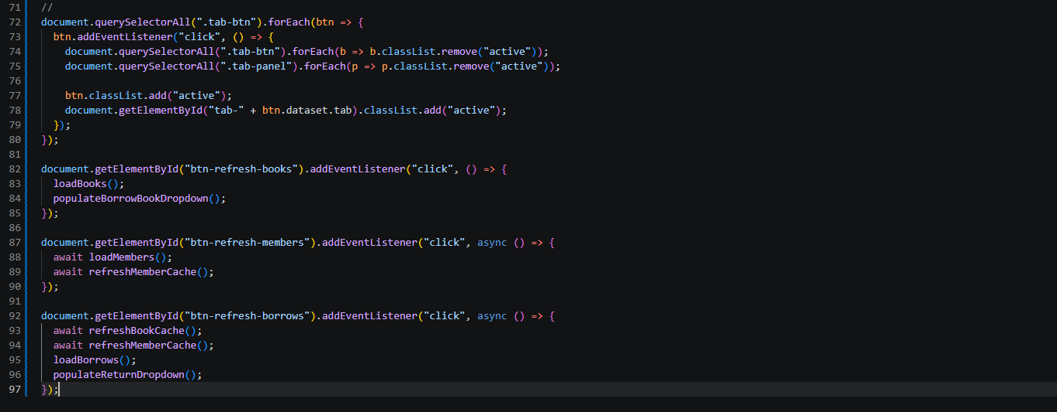

PART 5 - LOAD BOOKS INTO TABLE
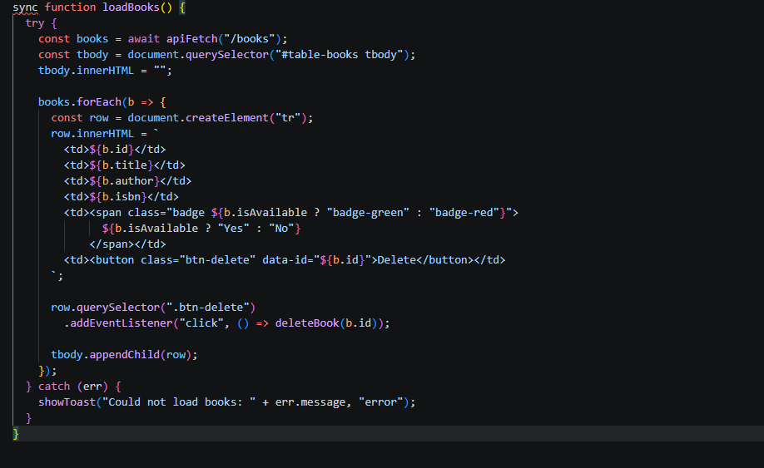
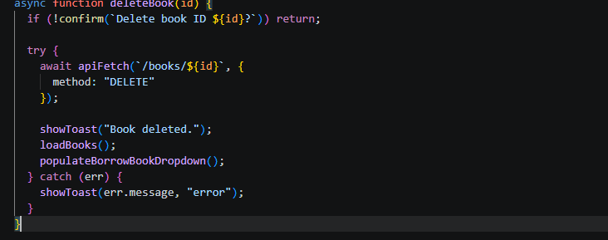
PART 6 - DELETE BOOK

PART 7 - ADD BOOK
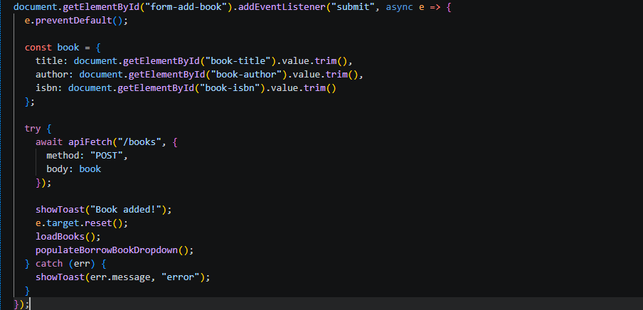
PART 8 - LOAD MEMBERS
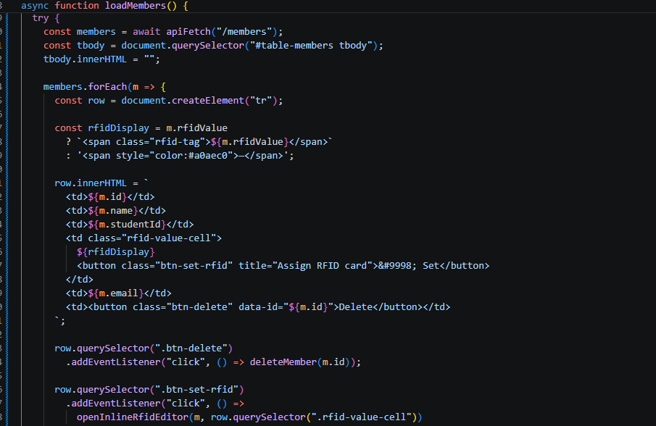
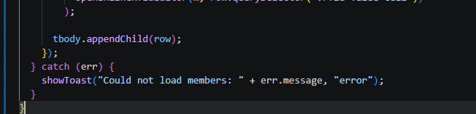
PART 9 - DELETE MEMBER
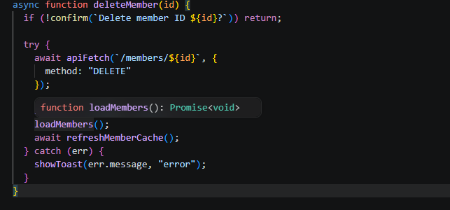
PART 10 - ADD MEMBER AND RFID VALUE
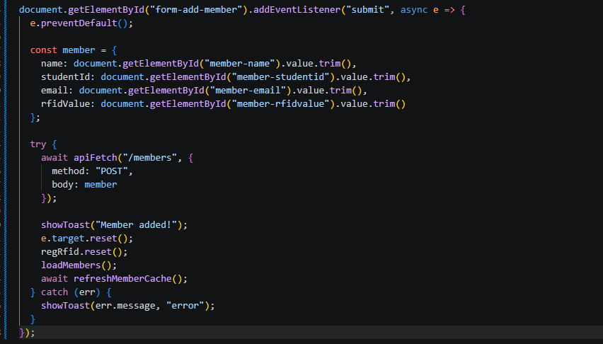
PART 11 - INLINE RFID EDITOR
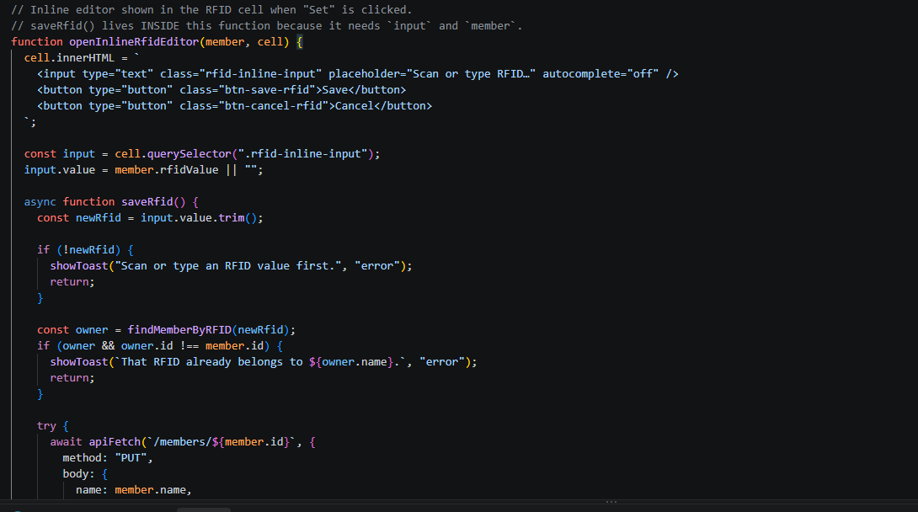

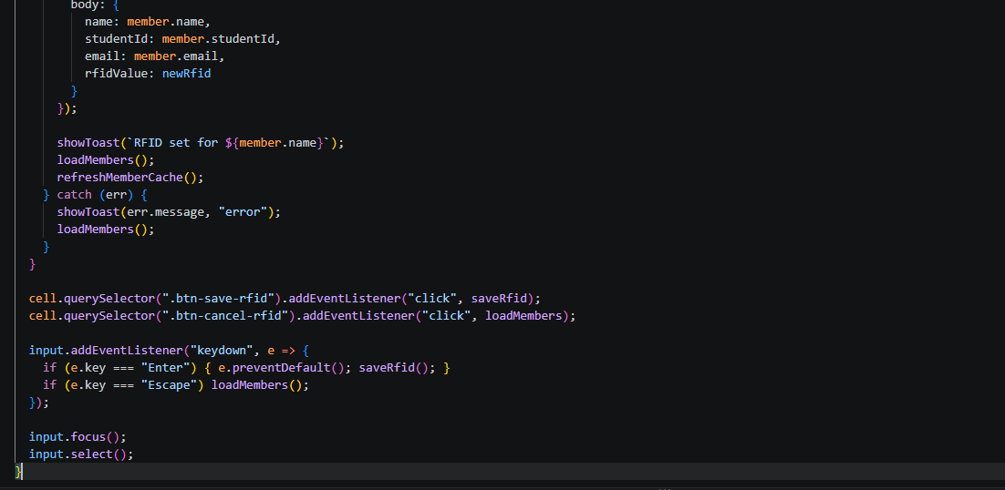
PART 12 - RFID WIDGET
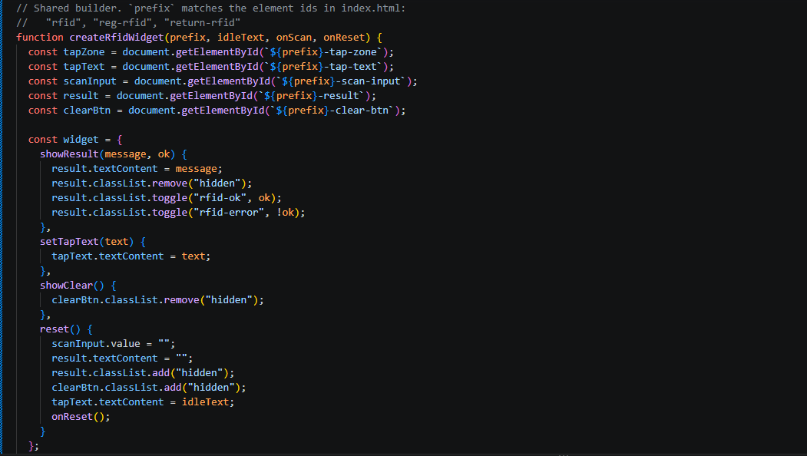
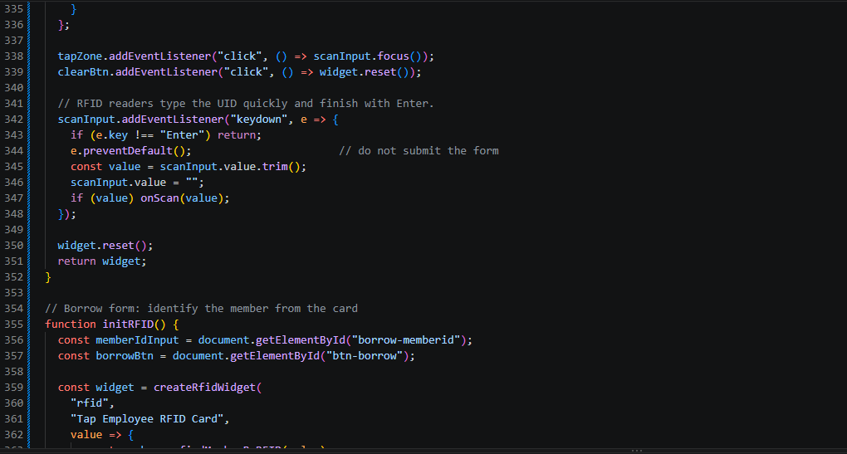

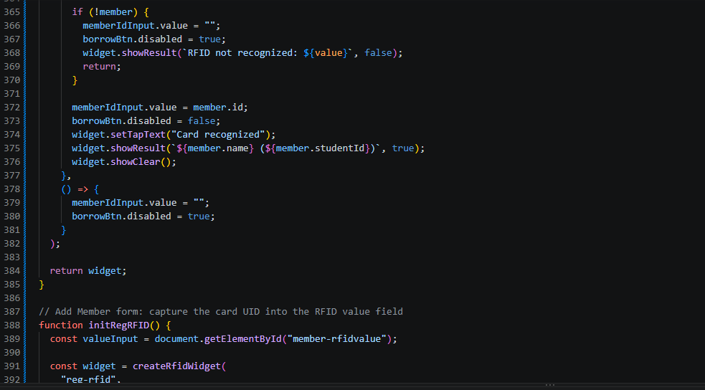
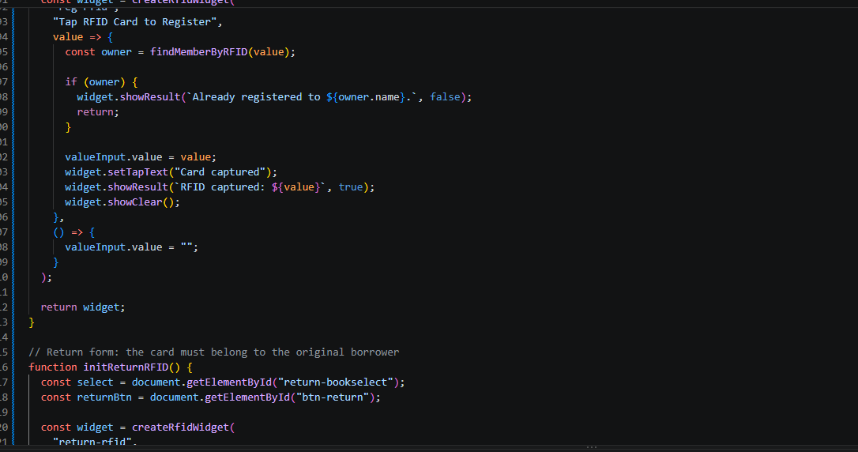
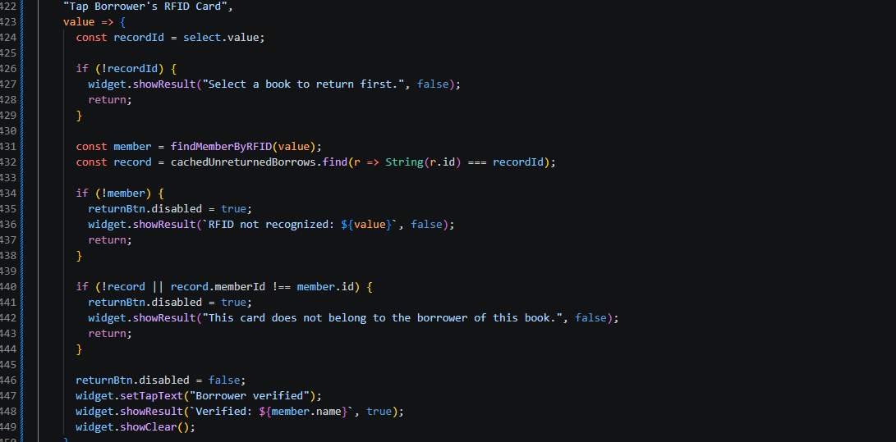

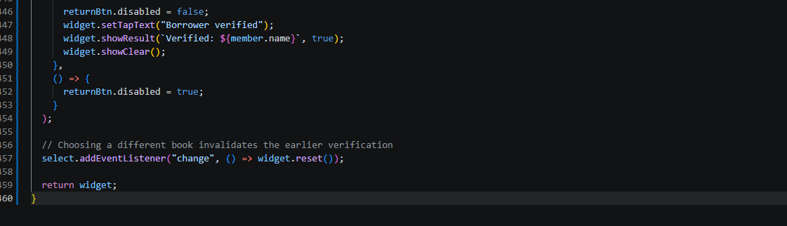

PART 13 - POPULATE BORROW BOOK
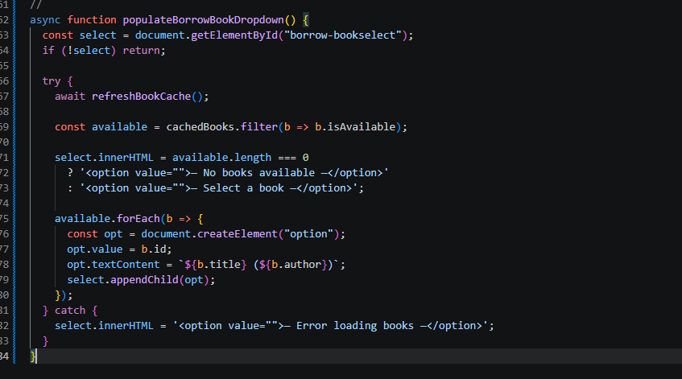
PART 14 - POPULATE RETURN BOOK
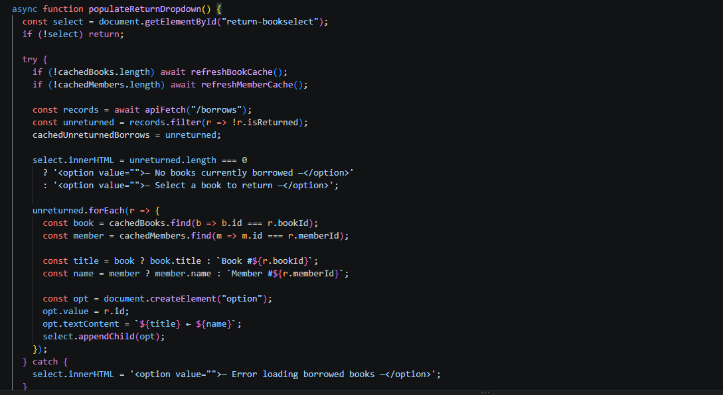

PART 15 - BORROW A BOOK
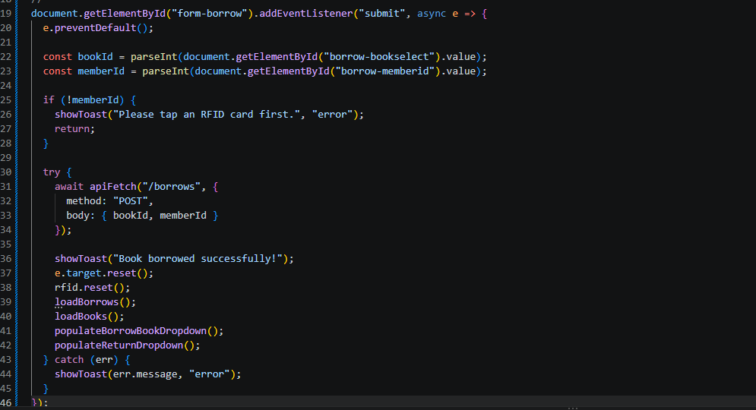
PART 16 - RETURN A BOOK
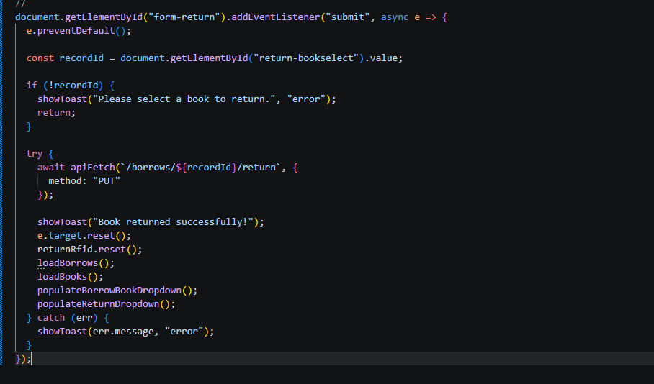
PART 17 - LOAD BORROW HISTORY TABLE
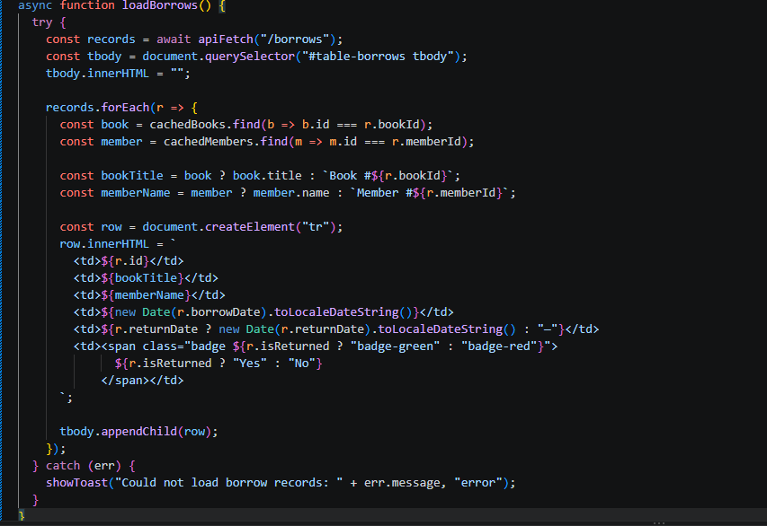
PART 18 - INITIAL PAGE LOAD
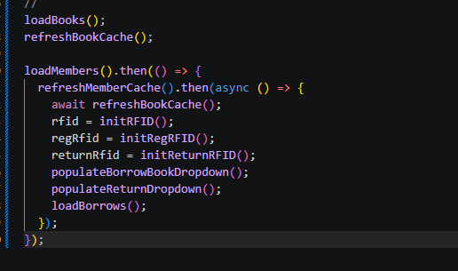

TEST 1 - START THE API
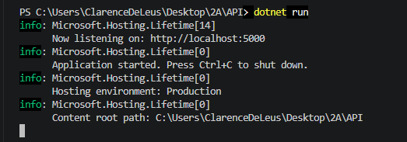

TEST 2 - OPEN THE FRONTEND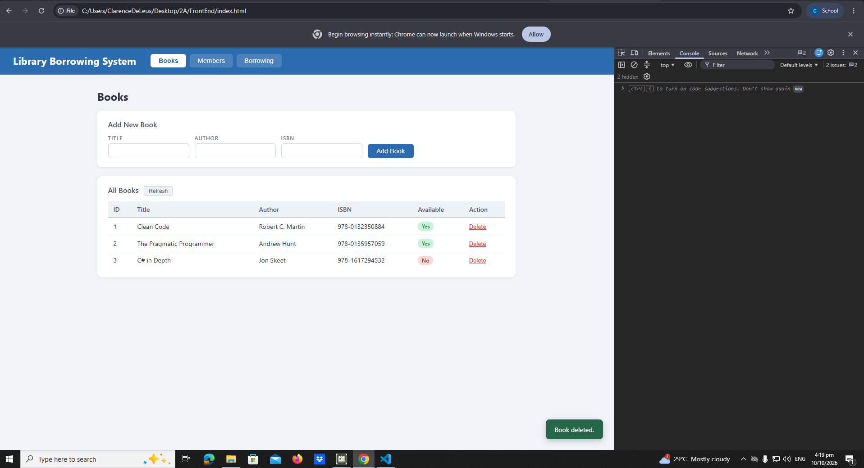

TEST 3 - TEST THE TABS
The tabs were already captured in early-03-tabs. No new screenshot here.

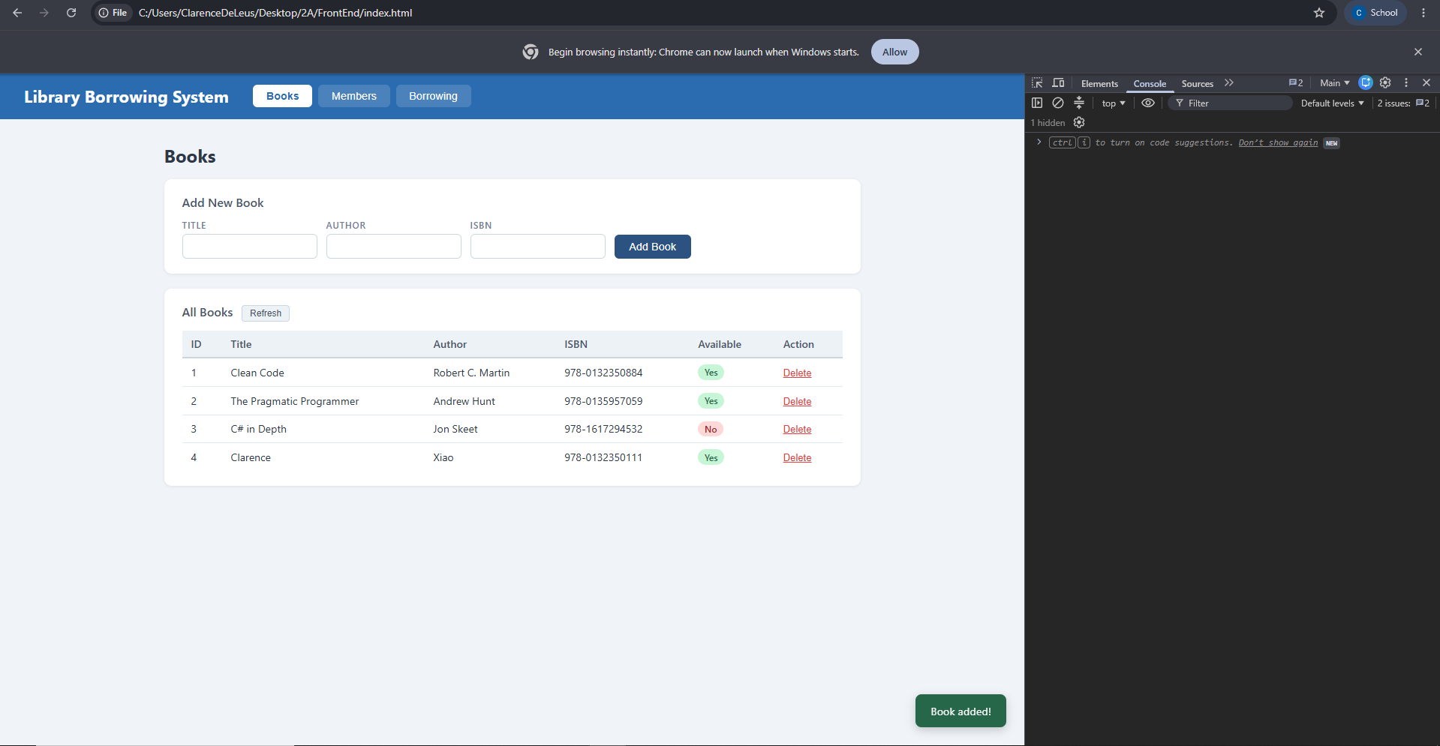
TEST 4 - TEST BOOKS

TEST 5 - TEST MEMBER

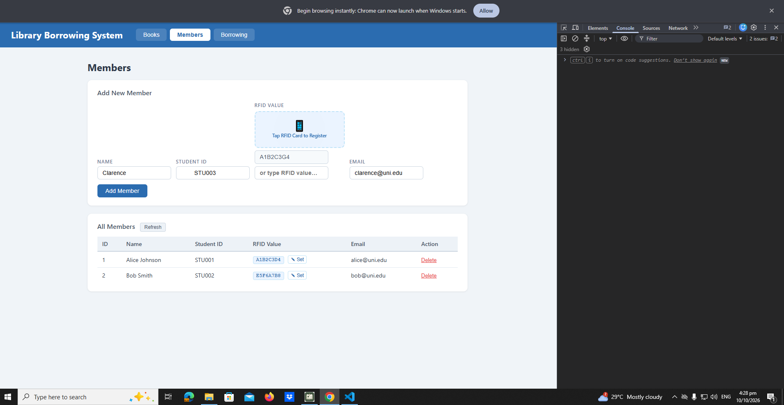

TEST 06 - ADD MEMBER
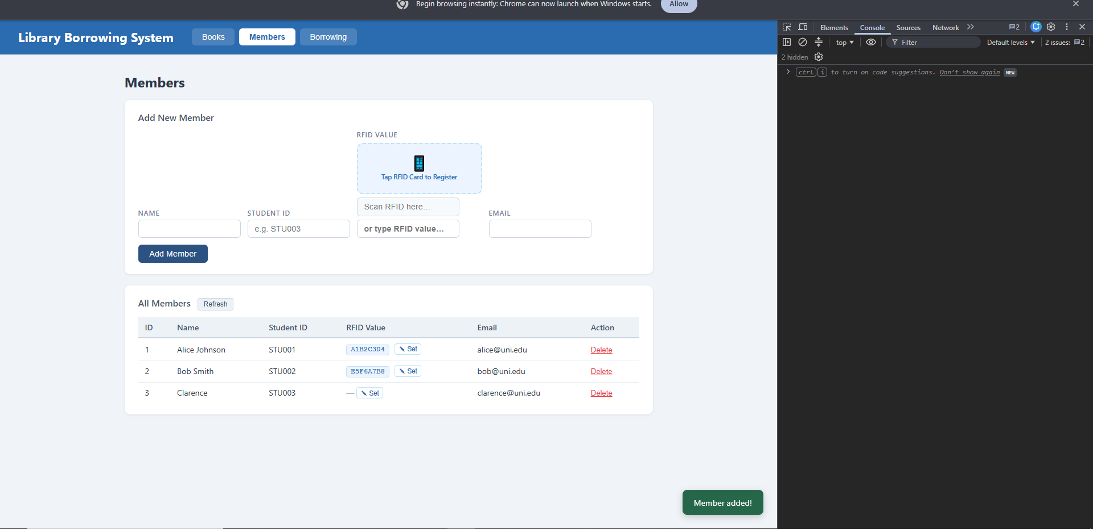

TEST 07 - SET THEN SAVE
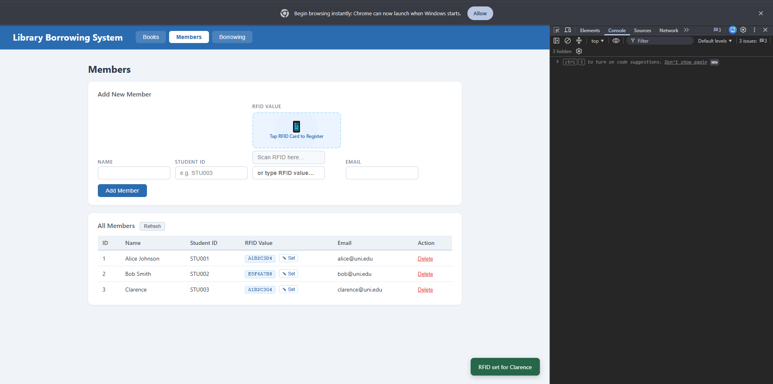
TEST 08 - DELETE MEMBER
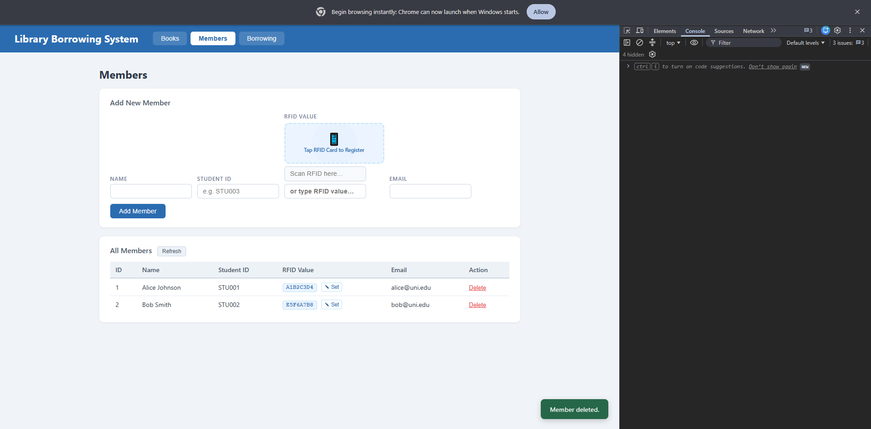
TEST 6 - TEST BORROWING

TEST - 09 - BORROW - RFID - RECOGNIZED

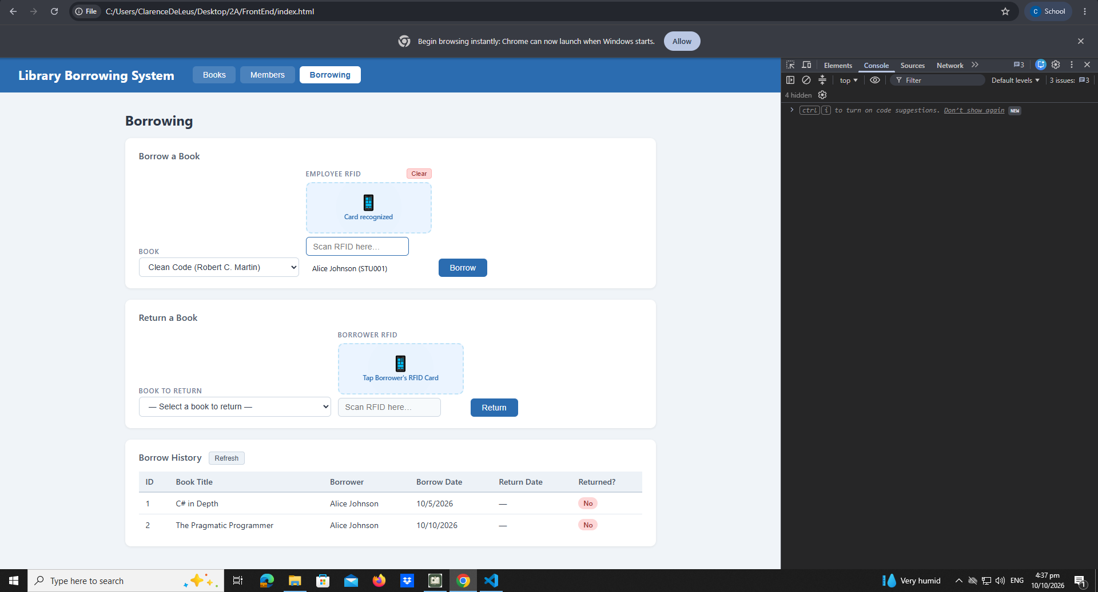

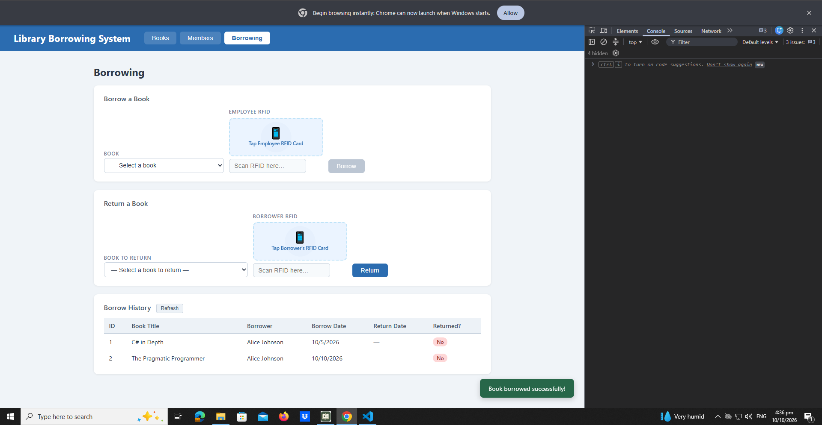
TEST 10 - BORROW SUCCESS

TEST - 7 TEST RETURNING

TEST 11 - RETURN WRONG CARD
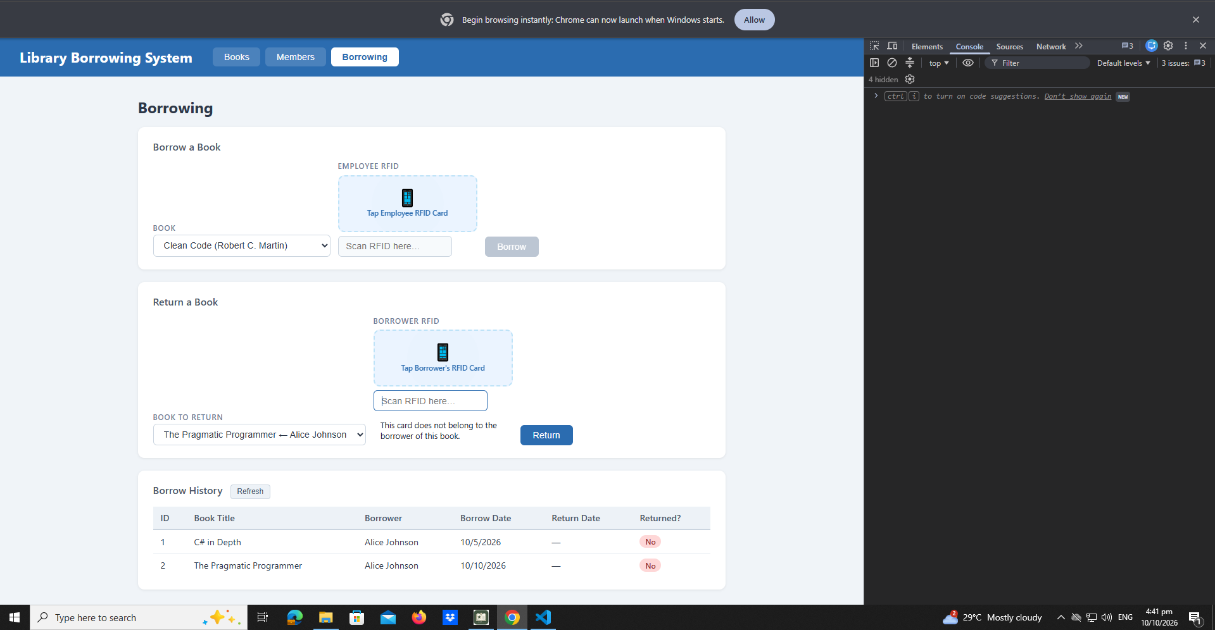

TEST 12 - RETURN VERIFIED
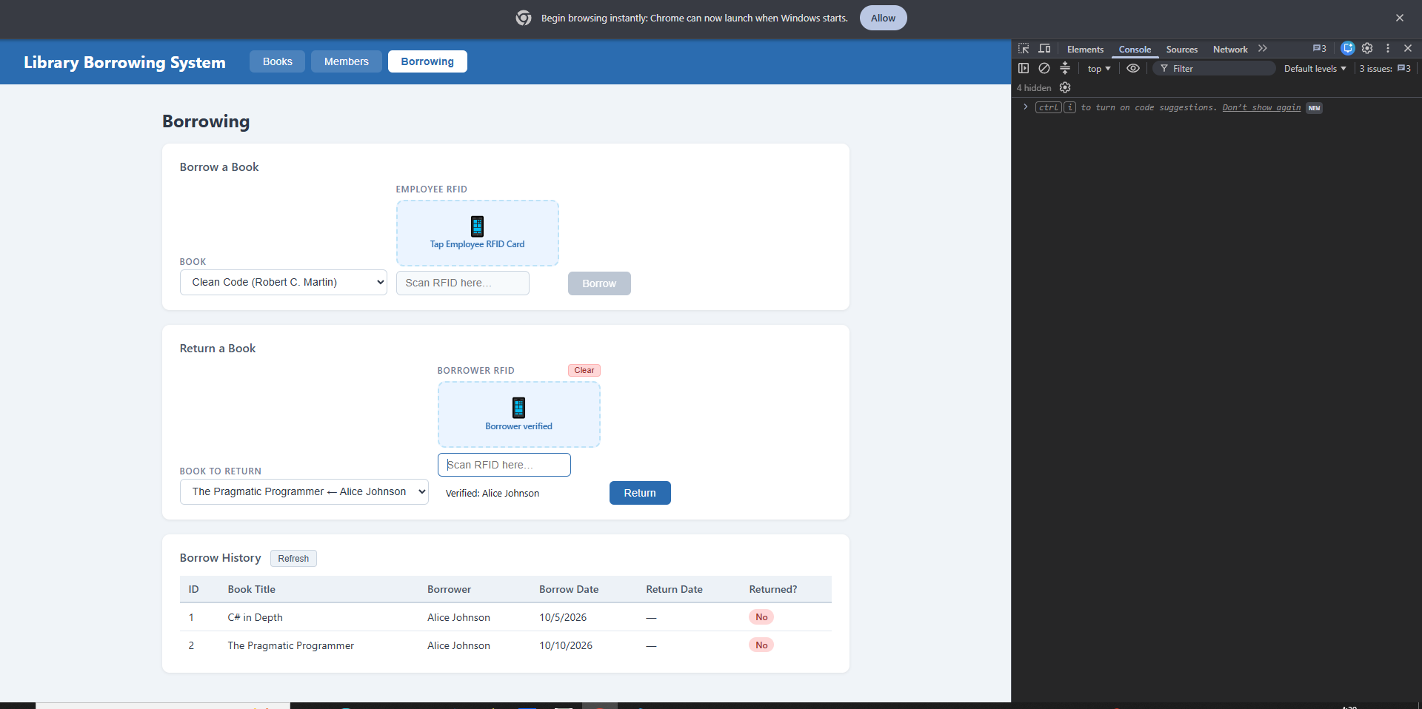

TEST 13 - RETURN SUCCESS

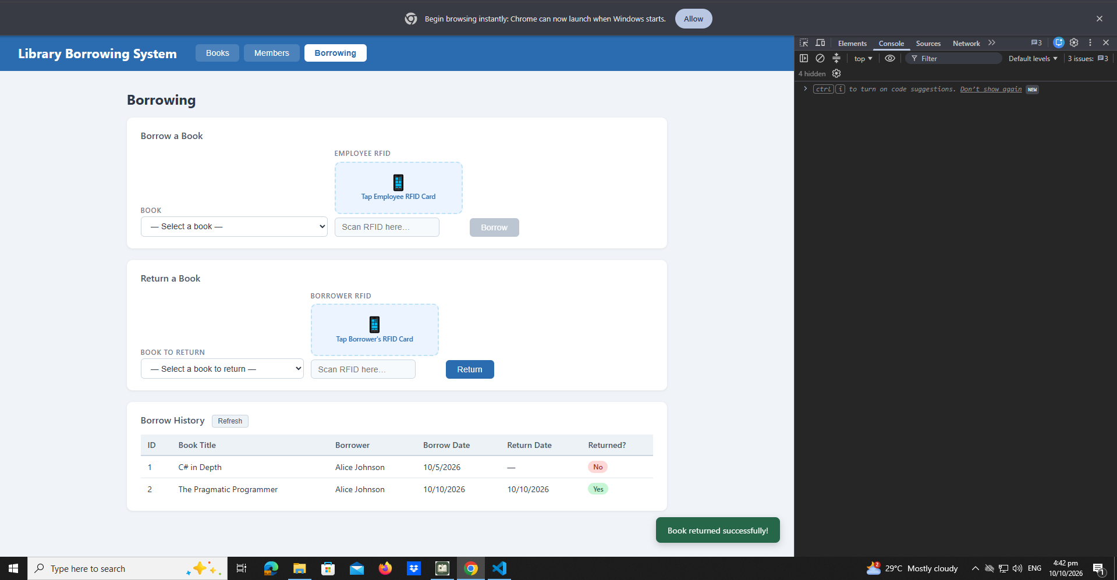

TEST 8 - FINAL CONSOLE CHECK

TEST 14 - FINAL CONSOLE CHECK

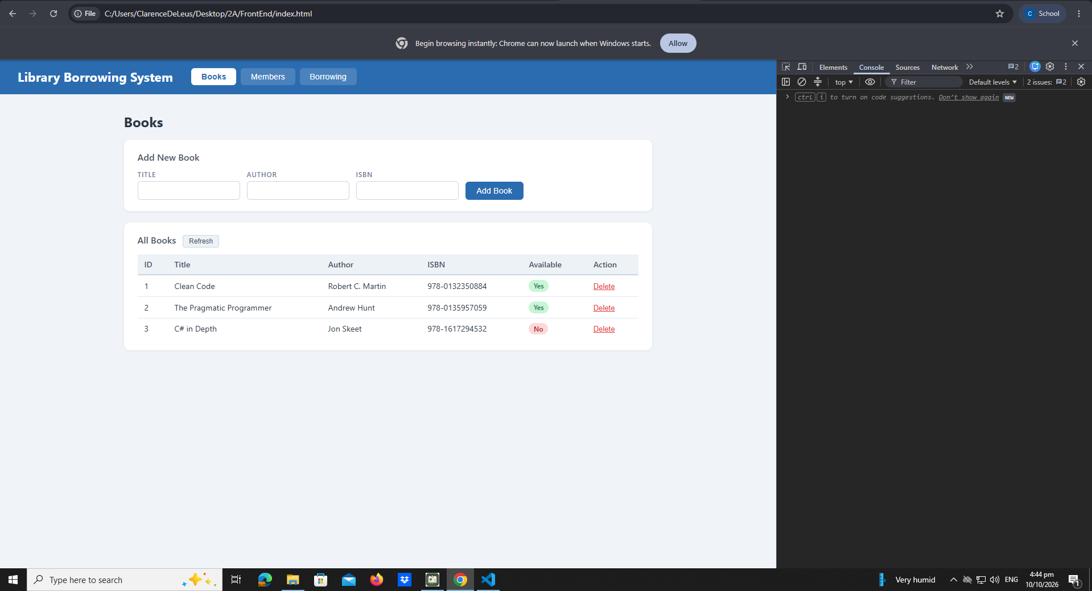

Student Reflection Questions
- What does apiFetch() do?
Sends requests to the API.
- Why do we use try/catch around API calls?
It can handle error, try/catch.
- What is the difference between POST and PUT?
Post is adds while put is to update .
- Why does RFID matching use rfidValue instead of studentId?
It can identifies the RFID card.
- Why do we refresh tables after adding, deleting, borrowing, or returning?
It can shows the updated of the data.
- Why does the Return dropdown use borrow record ID instead of book ID?
It can identifies the borrowing transaction.
- What happens if the same event listener is added to a form twice?
May run action twice.
- Why must the page-load code be at the bottom of the file?
To ensure that the elements are all ready.
- Why does an RFID reader need e.preventDefault() on the Enter key?
It can prevent unwanted form submission.

